# PART III: IMPLEMENTATION

# 6 Table Creation Script

## 6.1 *<* WARDEN *>* TABLE

CREATE TABLE WARDEN (

Warden_ID VARCHAR(30) NOT NULL PRIMARY KEY,

Fname varchar(15),

Lname varchar(15),

Gender varchar(20),

Address varchar(255),

Password NUMERIC(10),

Salary decimal(10,2) NOT NULL);

Not null constraint on salary since the Warden has to be paid.

## 6.2 *<* JOB_SALARY *>* TABLE

CREATE TABLE JOB_SALARY (

Job_Type VARCHAR(15) NOT NULL PRIMARY KEY,

Salary decimal(10,2) NOT NULL);

Not null constraint on salary since all jobs have a salary.

## 6.3 *<* STAFF *>* TABLE

CREATE TABLE STAFF(

staffID VARCHAR(30) NOT NULL PRIMARY KEY,

W_ID VARCHAR(30) REFERENCES WARDEN (Warden_ID) ,

Fname VARCHAR(20),

Lname VARCHAR(20),

Gender VARCHAR(20),

Job_type VARCHAR(15) REFERENCES JOB_SALARY(Job_Type),

Address VARCHAR(255));

## 6.4 *<* FLOOR*>* TABLE

CREATE TABLE FLOOR (

Floor_number VARCHAR(30) NOT NULL PRIMARY KEY,

Floor’s_type VARCHAR(30));

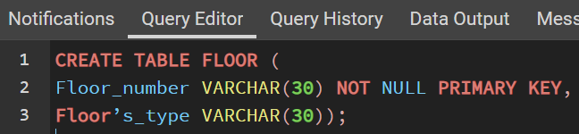

## 6.5 *<* PRISON_OFFICERS *>* TABLE

CREATE TABLE PRISON_OFFICERS(

ID VARCHAR(30) NOT NULL PRIMARY KEY,

F_number VARCHAR(30) REFERENCES FLOOR (Floor_number),

FOREIGN KEY (ID) REFERENCES STAFF (staffID) ON DELETE CASCADE);

## 6.6 *<* PRISON_COOK *>* TABLE

CREATE TABLE PRISON_COOK (

ID VARCHAR(30) NOT NULL PRIMARY KEY,

FOREIGN KEY (ID) REFERENCES STAFF (staffID) ON DELETE CASCADE);

## 6.7 *<* HAED_DOCTOR *>* TABLE

CREATE TABLE HEAD_DOCTOR(

ID VARCHAR(30) NOT NULL PRIMARY KEY,

FOREIGN KEY (ID) REFERENCES STAFF (staffID) ON DELETE CASCADE);

## 6.8 *<* YARD_OFFICER *>* TABLE

CREATE TABLE YARD_OFFICERS (

ID VARCHAR(30) NOT NULL PRIMARY KEY,

FOREIGN KEY (ID) REFERENCES STAFF (staffID) ON DELETE CASCADE);

## 6.9 *<* CELLS *>* TABLE

CREATE TABLE CELLS(

Cells_number NUMERIC(10) NOT NULL PRIMARY KEY,

F_number VARCHAR(30) REFERENCES FLOOR(floor_number),

Cells_Capacity NUMERIC(10) DEFAULT 2,

Cells_state varchar(20));

Since all cell capacities are the same, DEFAULT is used.

Default ‘unoccupied’ is used, until a prisoner occupies the cell.

## 6.10 *<* PRISONERS *>* TABLE

CREATE TABLE PRISONERS(

Prisoner_number NUMERIC(10) NOT NULL PRIMARY KEY,

Fname varchar(20),

Lname varchar(20),

Date_of_Arrival Date,

Date_of_Release Date,

C_number numeric(10),

FOREIGN KEY (C_number) REFERENCES CELLS (Cells_number) ON DELETE CASCADE);

## 6.11 *<* HEALTH_RECORDS *>* TABLE

CREATE TABLE HEALTH_RECORDS(

Prisoner_name varchar(50) NOT NULL,

P_number NUMERIC(10) NOT NULL,

State varchar(20),

Blood_type varchar(20),

Date_of_birth date,

Weight decimal(10,2),

Height decimal(10,2),

Disease_history varchar(255),

PRIMARY KEY(Prisoner_name, P_number),

FOREIGN KEY (P_number) REFERENCES PRISONERS (Prisoner_number) ON DELETE CASCADE);

(Prisoner_name) is partial key and (p_number) is a foreign key; those keys together will form the primary key for the weak entity.

## 6.12 *<* CRIMINAL_RECORDS *>* TABLE

CREATE TABLE CRIMINAL_RECORDS(

Prisoner_name varchar(50) NOT NULL ,

P_number NUMERIC(10) NOT NULL,

Prisoners_crime varchar(50) NOT NULL,

PRIMARY KEY(Prisoner_name, P_number),

FOREIGN KEY (P_number) REFERENCES PRISONERS (Prisoner_number) ON DELETE CASCADE);

(Prisoner_name) is partial key and (p_number) is a foreign key; those keys together will form the primary key for the weak entity.

Since all prisoners have committed crimes to enter the jail, prisoners_crime must be NOT NULL.

## 6.13 *<* VISITS *>* TABLE

CREATE TABLE VISITS(

Visitor_ID VARCHAR(30) NOT NULL,

P_number NUMERIC(10),

Visitor_name varchar(50),

Visitor_phone_number NUMERIC(15),

Visitor_address varchar(50),

Duration_of_visit TIME NOT NULL,

Time_of_visit TIME NOT NULL,

Number_of_visits NUMERIC(10),

FOREIGN KEY (P_number) REFERENCES PRISONERS (Prisoner_number) ON DELETE CASCADE);

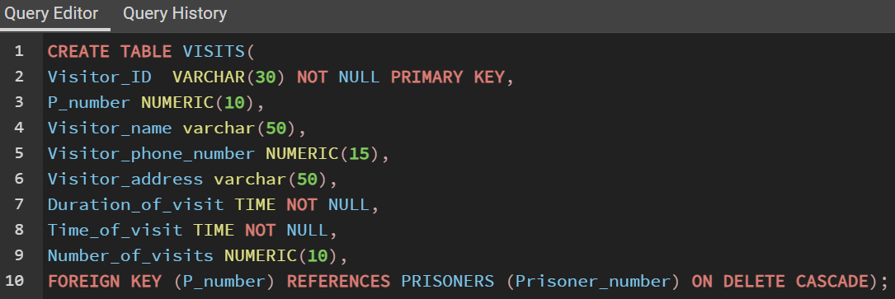

Since all visitors are allowed to visit prisoners for a limited time, Time_of_visit and Duration_of_visit must be measured to not break the prison rules, therefore the two attributes will have the constraint NOT NULL.

## 6.14 *<* ACTIVITY_REWARD *>* TABLE

CREATE TABLE ACTIVITY_REWARD(

Activity_Type varchar(50) NOT NULL PRIMARY KEY,

Reward varchar(50) );

## 6.15 *<* ACTIVITIES *>* TABLE

CREATE TABLE ACTIVITIES(

Activity_number NUMERIC(10) NOT NULL PRIMARY KEY,

Activity_Type varchar(50) REFERENCES ACTIVITY_REWARD (Activity_Type),

P_number NUMERIC(10) REFERENCES PRISONERS (Prisoner_number) );

## 6.16 *<* MANAGED *>* TABLE

CREATE TABLE MANAGED (

P_number NUMERIC(10) NOT NULL,

S_ID varchar(30) NOT NULL,

PRIMARY KEY(P_number, S_ID) ,

FOREIGN KEY (P_number) REFERENCES PRISONERS (Prisoner_number)ON DELETE CASCADE,

FOREIGN KEY (S_ID) REFERENCES STAFF (staffID) ON DELETE CASCADE );

## 6.17 *<* CELLS_FLOOR *>* TABLE

CREATE TABLE CELLS_FLOOR(

F_number VARCHAR(30) NOT NULL PRIMARY KEY,

NumberOFcells NUMERIC(100),

FOREIGN KEY (F_number) REFERENCES FLOOR (Floor_number) ON DELETE CASCADE );

## 6.18 *<* WARDEN_FLOOR *>* TABLE

CREATE TABLE WARDEN_FLOOR (

F_number VARCHAR(30) NOT NULL PRIMARY KEY,

Office_number NUMERIC(10),

FOREIGN KEY (F_number) REFERENCES FLOOR (Floor_number) ON DELETE CASCADE );

## 6.19 *<* PUNISHMENT *>* TABLE

CREATE TABLE PUNISHMENT (

Punishment_number NUMERIC(10) NOT NULL PRIMARY KEY,

W_ID VARCHAR(30) DEFAULT 200000,

Punishment_type varchar(255),

FOREIGN KEY (W_ID) REFERENCES Warden(Warden_ID) ON DELETE CASCADE);

Since (W_ID) is the always the same, DEFAULT is used.

## 6.20 *<* LAW_VIOLATORS*>* TABLE

CREATE TABLE LAW_VIOLATERS (

Prisoners_name varchar(50) NOT NULL ,

Punishment_number NUMERIC(10) NOT NULL ,

PRIMARY KEY(Prisoners_name, Punishment_number),

FOREIGN KEY (Punishment_number) REFERENCES PUNISHMENT(Punishment_number) ON DELETE CASCADE);

(Prisoners_name) is partial key and (punishment_number) is a foreign key; those keys together will form the primary key for the weak entity.

# 7 Constraints Script

This section will show some of the constraints we've put in place in our database. Keep in mind that these aren't the only database restrictions. It is merely a representation of some of the most fundamental and significant ones.

|  |  |  |
| --- | --- | --- |
| Business Rule | SQL Script | Table |
| Each staff member has a unique ID | Implementation: while creating the STAFF table  staffID VARCHAR(30) **NOT NULL PRIMARY KEY** | STAFF |
| Subclasses of STAFF must have an inherited ID. Since they are specializations of the superclass STAFF, if a STAFF member is deleted the data of all the referencing relations are deleted as well | FOREIGN KEY (ID) REFERENCES STAFF (staffID) **ON DELETE CASCADE**); | PRISON_OFFICERS  YARD_OFFICERS  HEAD_DOCTOR  PRISON_COOK |
| Each CRIMINAL RECORD has the PRISONER’S crime | Prisoners_crime varchar(50) **NOT NULL** | CRIMINAL_RECORDS |
| Each Cell that has fewer prisoners in them than the cell’s capacity is given a default label of “unoccupied” | Cells_state varchar(20) **DEFAULT 'Unoccupied'**); | CELLS |

# 8 Queries and Transactions

The majority of our important queries and transactions do not need to be complicated. However, the system may require some more complicated queries and transactions.

## 8.1 <Average salaries >

**Query in Natural Language (English)**

This query will retrieve the average salary of each job type with an average salary greater than the specified department average salary.

Our database will be used in this context by users to get the average salary of each essential job type for the STAFF members (Prison officers, yard officers, head doctor, prison cook).

**SQL Script**

SELECT AVG(salary) AS "Ave Salary", job_type

FROM job_salary

Group by job_type

HAVING AVG(salary) > (select avg(salary)

FROM job_salary

Where job_type='YardOfficer');

**Caption of the First Five Rows of the Output**

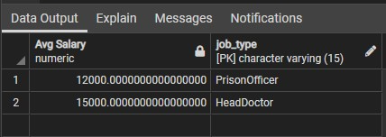

## 8.2 *<Specify prisoners with certain characteristics>*

**Query in Natural Language (English)**

This query will display the Prisoner number of all prisoners who will be released after the date

(1-1-2026), and their initials are not the letter (R).

**SQL Script**

select PRISONERS.Prisoner_number

from PRISONERS

where Date_of_Release > '1-1-2026' AND Fname NOT LIKE 'R%';

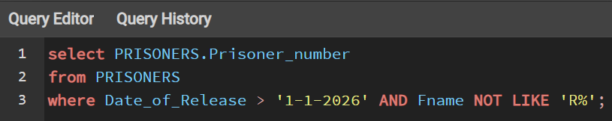

**Caption of the First Five Rows of the Output**

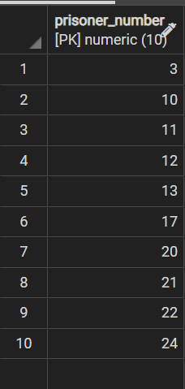

## 8.3 *<Specify robbers>*

**Query in Natural Language (English)**

Print ID, first name, and last name of prisoners who have committed robbery.

**SQL Script**

Select PRISONERS.Prisoner_number, Fname,Lname

From PRISONERS JOIN CRIMINAL_RECORDS ON Prisoner_number = P_number

Where PRISONERS.Prisoner_number in( select P_number

From CRIMINAL_RECORDS

Where Prisoners_crime LIKE 'Robbery');

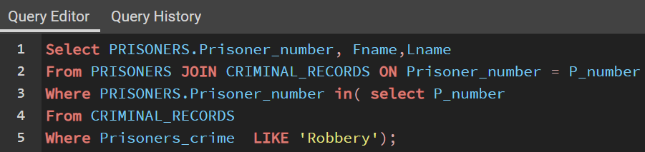

**Caption of the First Five Rows of the Output**

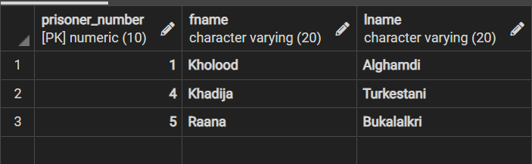

## 8.4 *<Salary Raise>*

**Query in Natural Language (English)**

This query will raise the salary of all employees by 10%.

**SQL Script**

SELECT job_type, Salary, Salary*1.10 AS Salary_After_Bonus

FROM JOB_SALARY;

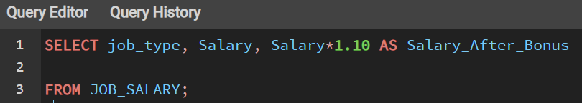

**Caption of the First Five Rows of the Output**

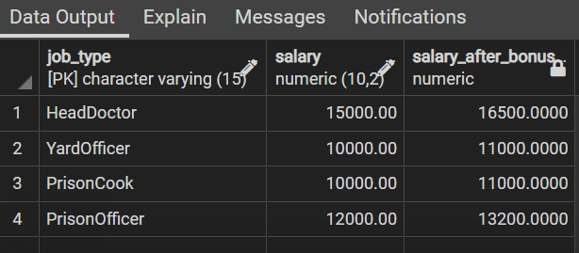

## 8.5 *<Specify jobs with less than two members >*

**Query in Natural Language (English)**

This query will display jobs that have less than 2 members working in them including their names.

**SQL Script**

SELECT Fname,Lname, Job_type

FROM STAFF WHERE Job_type IN

(SELECT Job_type FROM STAFF

GROUP BY Job_type HAVING COUNT(*)<2);

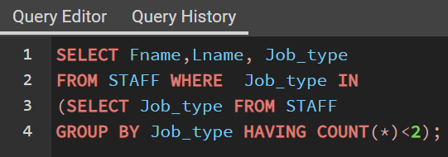

**Caption of the First Five Rows of the Output**

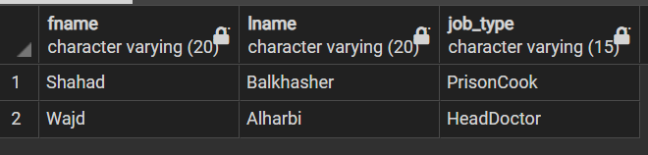

## 8.6*<Total Number of Staff Members Per Job Type>*

**Query in Natural Language (English)**

This query will display names of the jobs and the numbers of staff memebrs working in descending order. We used the aggregate function COUNT here to find the total number of members working in each job type.

**SQL Script**

SELECT job_type, COUNT(*) AS NUMBER_OF_STAFF_PER_JOB_TYPE

FROM STAFF

GROUP BY Job_type

ORDER BY COUNT(*) DESC;

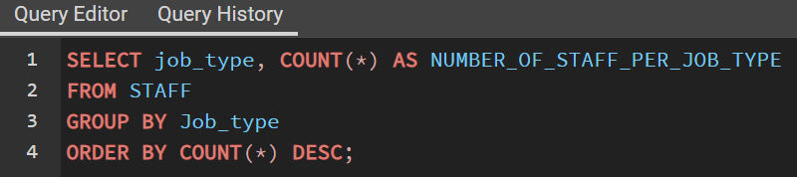

**Caption of the First Five Rows of the Output**

## 8.7*<The Largest Number of Staff Members in a Job Type>*

**Query in Natural Language (English)**

This query will display the largest number of staff members that are working in a job among all job types. We used nested aggregate functions (MAX, COUNT).

**SQL Script**

SELECT MAX(NUMBER_OF_STAFF_PER_JOB_TYPE) AS "The Largest Number of Staff Members in a Job Type"

FROM(SELECT Job_type, COUNT(*)AS NUMBER_OF_STAFF_PER_JOB_TYPE

FROM STAFF

GROUP BY Job_type)

AS SubQueryAlias;

**Caption of the First Five Rows of the Output**

## 8.8 Update Example

### 8.8.1 example

**Update in Natural Language (English)**

UPDATE the phone number of the visitor with ID (10015).

**SQL Script**

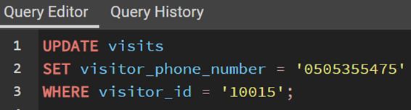

**Before Update:**

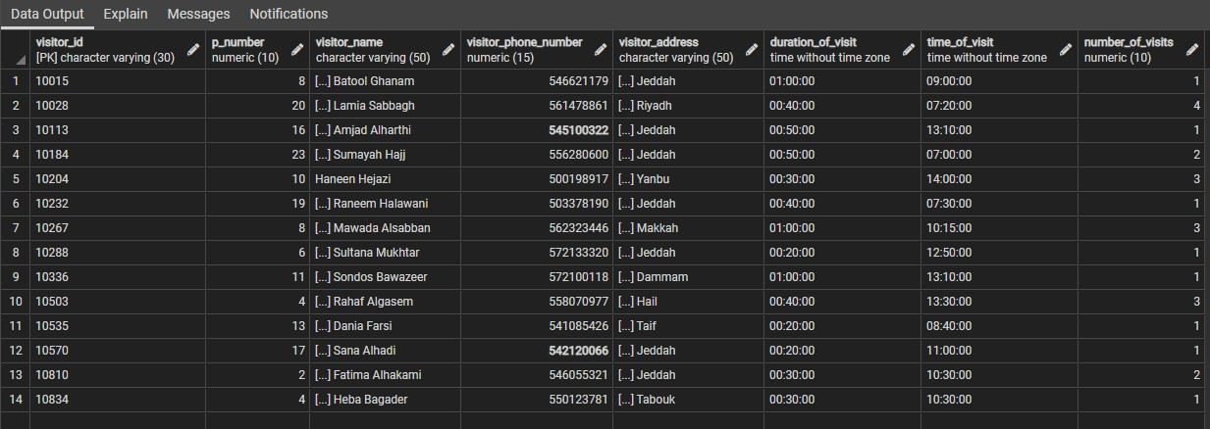

**After Update:**

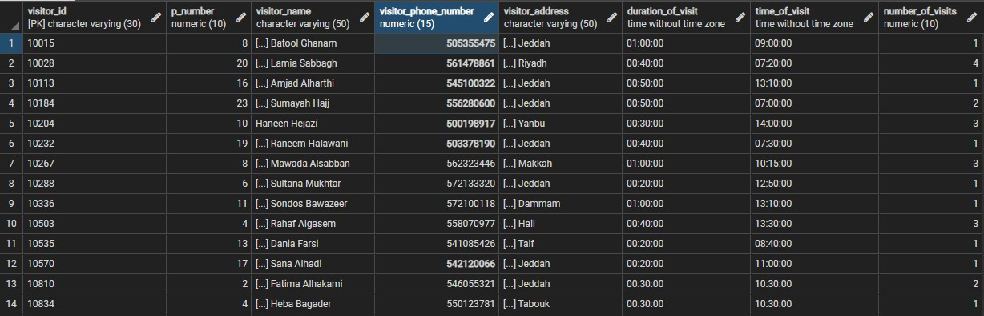

### 8.8.2 example

**Update in Natural Language (English)**

Update the cell’s capacity of the cell with number 30 from 2 to 1.

**SQL Script**

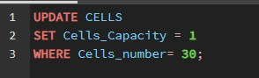

**Caption of the Output before update:**

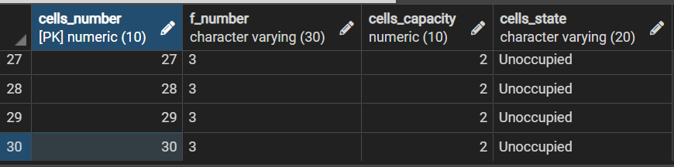

**Caption of the Output after update:**

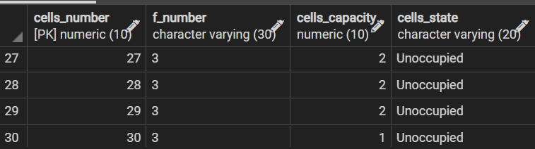

## 8.9 Delete Example

### 8.9.1 example

**Delete in Natural Language (English)**

Delete the prisoners with the number (00025).

**SQL Script**



**Caption of the Output before delete:**

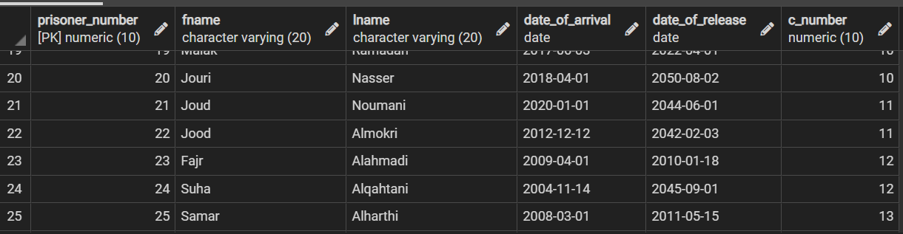

**Caption of the Output after delete:**

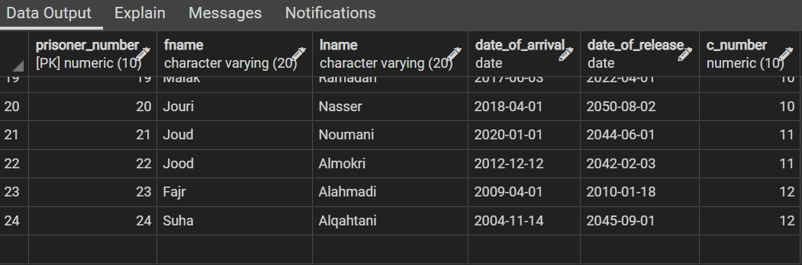

### 8.9.2 example

**Delete in Natural Language (English)**

Delete the STAFF member with the ID (20021).

**SQL Script**



**Caption of the Output before delete:**

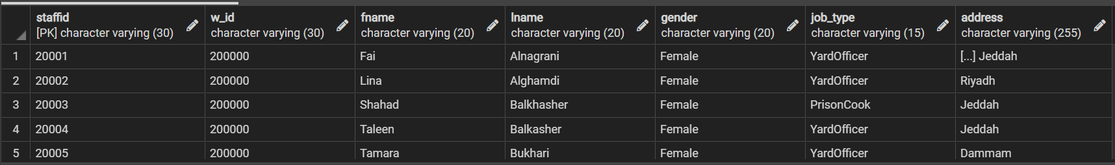

**Caption of the Output after delete:**

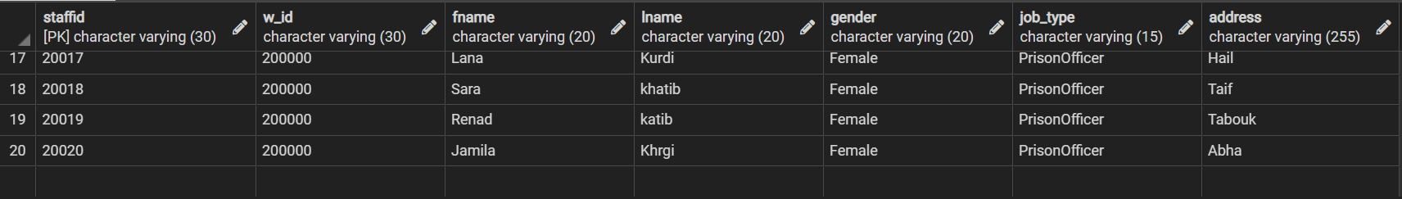

# 9 APPENDIX

## WARDEN TABLE



## JOB_SALARYTABLE

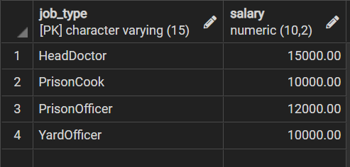

## STAFFTABLE

**FLOOR TABLE**

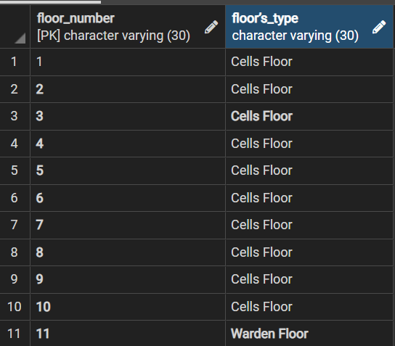

**PRISON_OFFICERSTABLE**

## PRISON_COOKTABLE

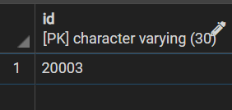

**HEAD_DOCTORTABLE**

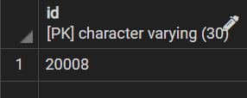

## YARD_OFFICERTABLE

## CELLSTABLE

## PRISONERSTABLE

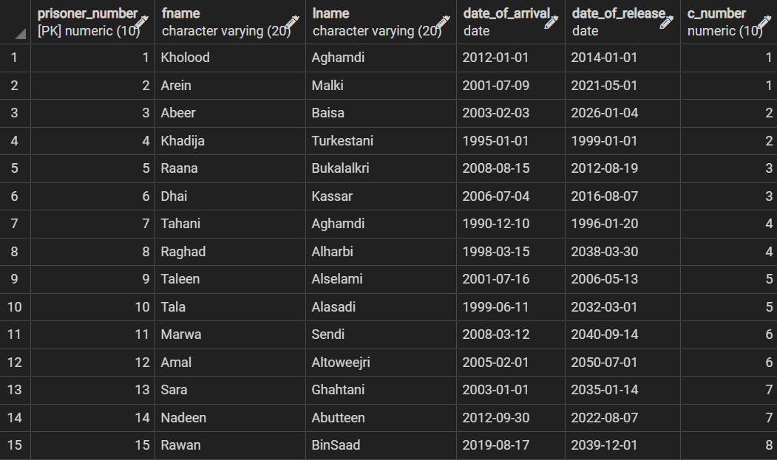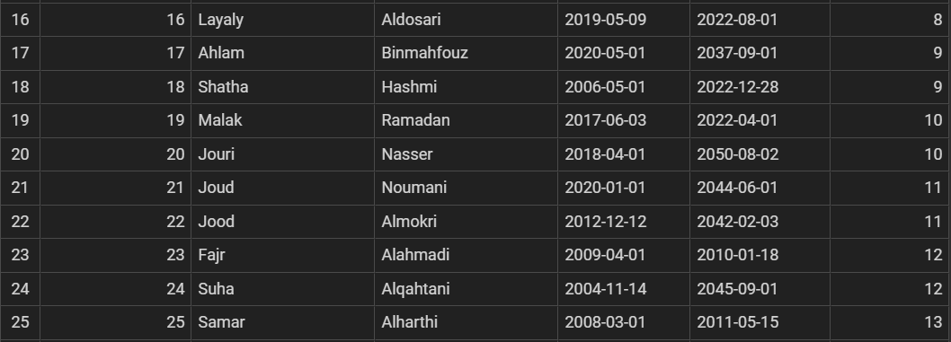

## HEALTH_RECORDSTABLE

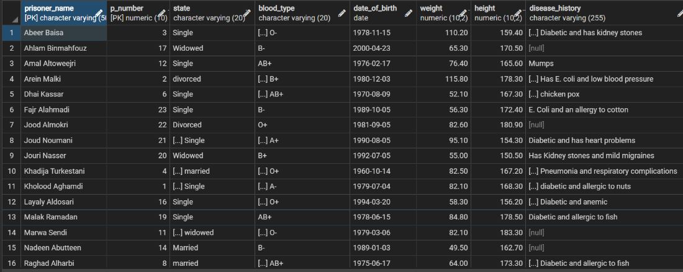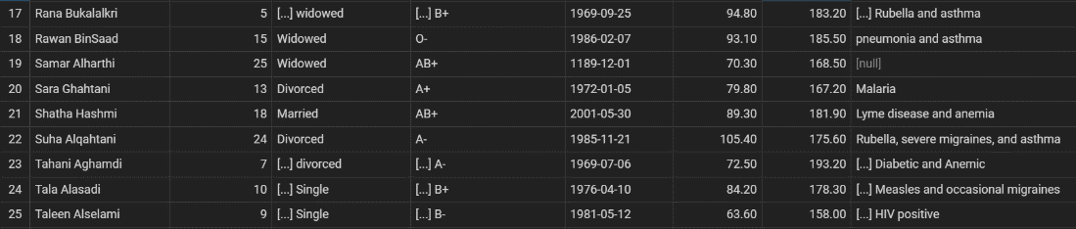

## CRIMINAL_RECORDSTABLE

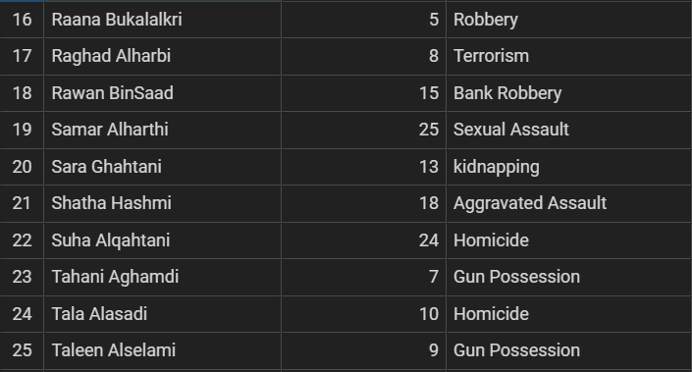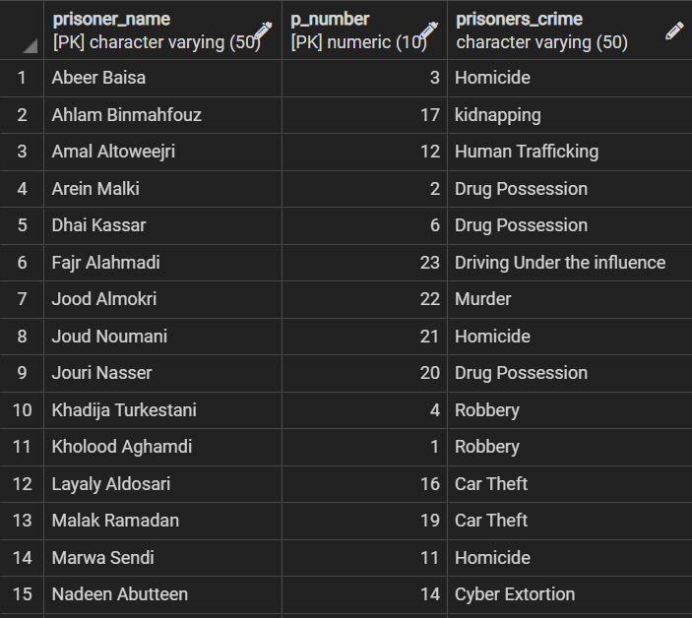

## VISITSTABLE

## ACTIVITY_REWARDTABLE

## ACTIVITIESTABLE

## MANAGEDTABLE

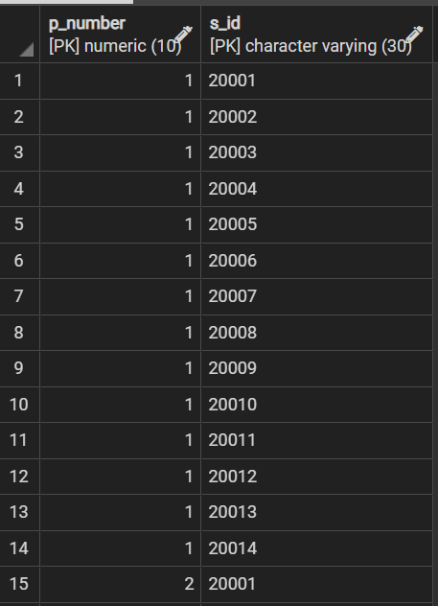

And so on.

## CELLS_FLOORTABLE

## WARDEN_FLOORTABLE

## PUNISHMENTTABLE

## LAW_VIOLATORS TABLE

